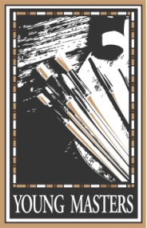

Young Masters College Scholarship Application
Phil and Karen Korell scholarship Fund

Through a generous donation by the KT Rose Foundation, the Young Masters is proud to offer several college scholarships annually. These scholarships, from the Phil and Karen Korell Art Scholarship Fund, are up to $2500 and are available statewide. Applicants may include not only art majors, but students who plan to focus on the fields of art education, graphic art and design, architecture, or drafting. Each year, the scholarship deadline is on February 15 at 5:00 PM. If February 15 is on a weekend, the deadline is at 5:00 PM on the Monday following that weekend.

Classroom scholarship opportunities are funded in part by the generosity of our sponsors.

Date:
Student Name:
Student Address:
Student Phone:
Student Email Address:
Student’s High School:
Name & location of intended Post-Secondary School:
Student Signature:
Within the application packet, include:
Resume (including elements below when applicable)
- List student shows entered and awards won
- List art projects you have participated in
- List participation in community art projects
- List docent or volunteer work done at a museum or art show
- List work done at a gallery or frame shop
- List participation in activities related to your intended field of study
6-10 photographs of your art/design work
Description of how the scholarship money will be used*
Two letters of recommendation, at least one of which is an art teacher. Letters should each be in a sealed envelope with the author’s signature on the seal.
Submit a resume with a CD or thumb drive of photographs to:
Out West Young Masters Scholarship Program – PO Box 6241 – Great Falls, MT 59406-8241

*Scholarships are restricted to tuition, fees, and supplies, and will be paid directly to the accredited institution.

